Lab 5: Build a Database server.

COS20019: Cloud computing architecture

Tran Thanh Minh

103809048

**Task 1 : Create a security group for the RDS DB instance**

1. Create security group and give access to the MYSQL A screenshot of a computer

   Description automatically generated

**Task 2: Create a DB Subnet Group**

1. Follow the instruction of the lab to create the subnet group for the databaseA screenshot of a computer

   Description automatically generated

**Task 3: Create an Amazon RDS DB instance**

1. Using engine MySQL for the creating database A screenshot of a computer

   Description automatically generated with medium confidence
2. Configure the credentials details for the database A screenshot of a computer

   Description automatically generated
3. Configure the instance and the storage for the database A screenshot of a computer

   Description automatically generated
4. Configure the connectivity with the db subnet group has been created and the security groupA screenshot of a computer

   Description automatically generated
5. Take the endpoint value of the database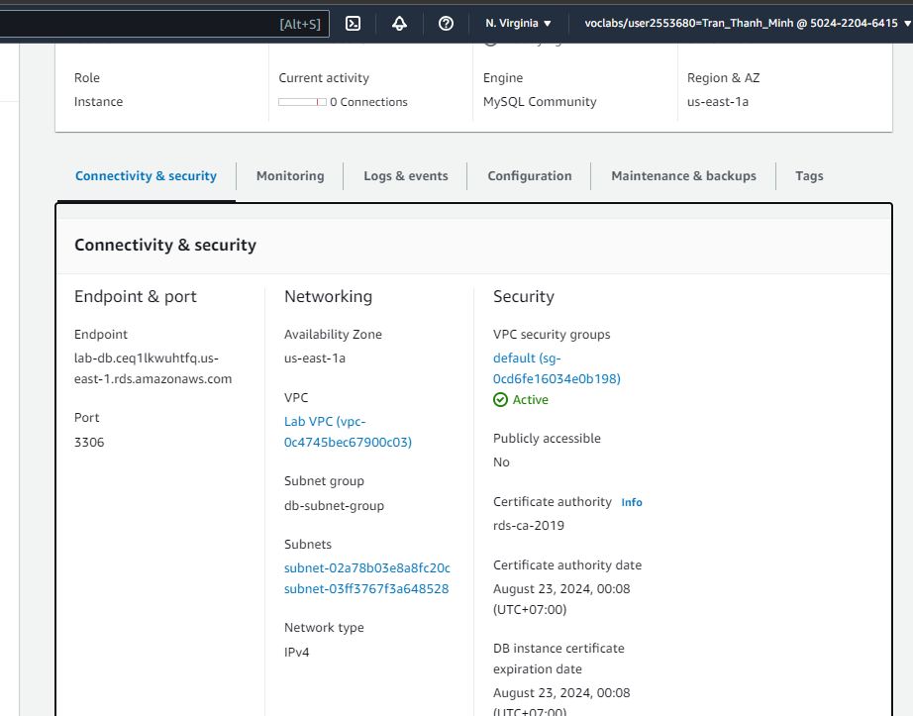

**Task 4: Interact with your DB**

1. Get the webserver IPA screenshot of a computer

   Description automatically generated
2. Info about ec2 is displayed A screenshot of a computer

   Description automatically generated
3. Enter details of database 